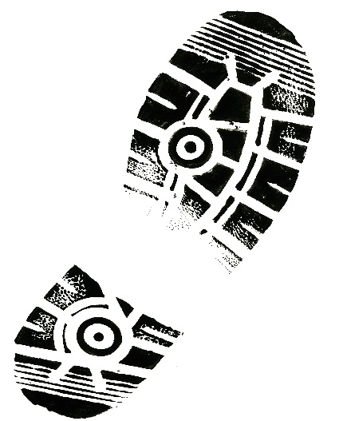

Schedule of Events
Saturday, June 6, 2020

8:00 AM - Registration at Downtown Glasgow
Milk River Catfish Days/
Glasgow Chamber
Catfish Crawl
$20 Adults $10- Grades K-12 Free-Under 5 years old
$50 Immediate Family Only Cap
9:00 AM – 5 K Walk/Run
9:30 AM – 1 Mile Walk/Run

Catfish Crawl Entry Form

Individual Events: Age Bracket (circle one):

_____5K Run/Walk Under 5 years old Grade K-6th

_____1 Mile Run/Walk Adult

Event:_________________________________ Event:___________________________________

Name:________________________________ Name:___________________________________
Mailing Address:___________________________ Mailing Address:______________________________

City/State/Zip_________________________ City/State/Zip_____________________________

Phone (daytime):______________________ Phone (daytime):__________________________
E-Mail: _______________________________ E-Mail: ___________________________________

Male______________Female____________ Male______________Female_________________
Age: _________Birthdate:_______________ Age:______________ Birthdate:_______________

Event:________________________________ Event:__________________________________

Name:________________________________ Name:__________________________________
Mailing Address:___________________________ Mailing Address:_____________________________

City/State/Zip__________________________ City/State/Zip____________________________

Phone (daytime):_______________________ Phone (daytime):_________________________
E-Mail: ________________________________ E-Mail: __________________________________

Male___________Female___________ Male_____________Female________________
Age: ___________Birthdate______________ Age:____________Birthdate:_______________

***Sign waiver of liability on the back

Waiver of Liability
This is an important legal document, read carefully before signing!

Even with the traffic control and EMS on site, I realize the event is physically strenuous, possible
adverse weather, and there may be vehicles on the course. I nevertheless wish to compete and
assume the risk on any injury at the crowded start, or on the course. I give up any claims for
injuries that I may sustain, including death, and agree to hold harmless, “The Milk River Catfish Crawl,”
its directors and officers, employees and volunteers, suppliers, contractors, sponsors, the State of
Montana, and anyone else connected with the race. I agree that the race may use any photos
taken of me without compensation. I have read and understand the Waiver of Liability for The
Milk River Catfish Crawl. I am making this agreement and paying my entry fee in exchange for the
privilege of competing in this race and using the facilities provided by the race.

Participants under 18 must have a parent or guardian sign.

Date________ Signature___________________________________ Age__________

Date________ Signature___________________________________ Age__________

Date________ Signature___________________________________ Age__________

Date________ Signature___________________________________ Age__________

SPONSORED BY:
Glasgow Area Chamber of Commerce & Agriculture

